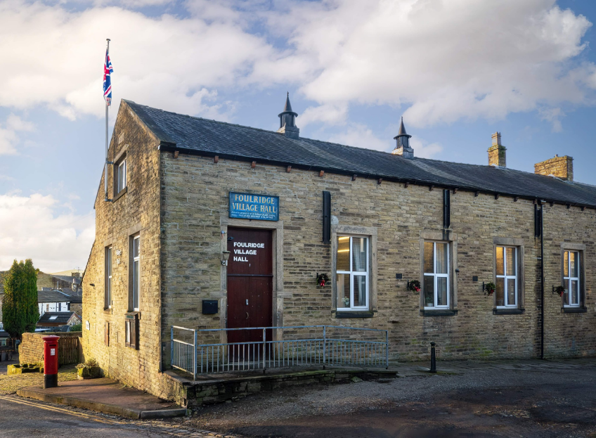
FOULRIDGE VILLAGE HALL TRUSTEES

Village Hall Trustees Meeting
Minutes of Meeting held at 7.00pm on Tuesday 7th April 2026

1. Welcome and Apologies for Absence
The Chair, Cllr K Salter, welcomed all attendees to the meeting.
Trustees Present:
Cllr K Salter (Chair),Cllr Mulligan (Vice Chair), Cllr A Salter, Cllr Rigby, Cllr Halliday, Cllr Robinson, Cllr Whitfield
Also Present: Cllr Knowles, Mr Eccles (Caretaker)
Absent: Cllr Dixon

2. Approval of Previous Minutes
The minutes of the previous meeting were approved as a true and accurate record.

3. Matters Arising

There were no matters arising.

4. Village Hall Update
Caretaker’s Report:
The Caretaker reported that there are currently no new issues requiring attention and advised that Village Hall bookings remain quiet at present.
He confirmed that the PAT testing has been scheduled and the fire alarm testing is due to take place at the end of the month. He also confirmed that he is awaiting confirmation from the gas engineer regarding a date to carry out the gas service.

5. Finance Report
The following invoices for March were reviewed and approved for payment:

Repacement tin openers | 11.94 | 03.03.26
Hand paper towels | 29.49 | 03.03.26
British Gas Gas 03.02.26-04.03.26 | 112.08 | 18.03.26
Waterplus 07.02.26-04.03.26 | 67.88 | 26.03.26
3 x keys cut | 14.00 | 11.03.26
British Gas - Electric 14.02.26-14.03.26 | 176.09 | 176.09

Resolved:
The invoices totalling £411.48 were approved for payment.
The end of year accounts for 2025/26 were noted.

6. Trustee Responsibilities and Governance
- The Trustee Responsibilities and Governance document is still in progress and will be brought to a future meeting for final approval
- The Safety and Compliance Checklist was noted – Trustees are aware that the Fixed Wiring Electrical testing (EICR) is overdue and agreed that arrangements will be made to carry this out.

7. Correspondence

No correspondence was received

8. Date of next meeting

Members noted that the next scheduled meeting falls on a Bank Holiday. Trustees agreed that the meeting will instead be held on Monday 11th May 2026.

Date of Next Meeting
Monday 11th May 2026 at 7:00pm

