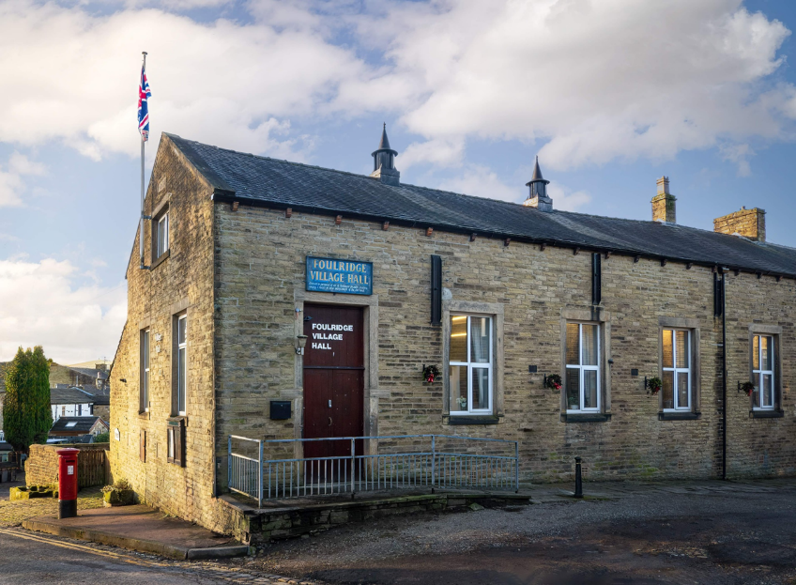
FOULRIDGE VILLAGE HALL TRUSTEES

Village Hall Trustees Meeting
Minutes of Meeting held at 7.00pm on Monday 2nd March 2026

1. Welcome and Apologies for Absence
The Vice Chair, Cllr Mulligan, welcomed all attendees to the meeting.
Trustees Present:
Cllr Mulligan (Vice Chair), Cllr Rigby, Cllr Halliday, Cllr Robinson, Cllr Whitfield
Also Present: Cllr Knowles, Mr Eccles (Caretaker)
Apologies: Cllr K Salter, Cllr A Salter, Cllr Dixon

2. Approval of Previous Minutes
The minutes of the previous meeting were approved as a true and accurate record.

3. Matters Arising

There were no matters arising.

4. Village Hall Update
Caretaker’s Report:
The Caretaker advised that there were no new issues to report. Village Hall bookings are currently quiet.
Cllr Knowles advised that the new table tennis group appears keen to continue and is likely to become a regular user group of the Hall.

5. Finance Report
The following invoices for February were reviewed and approved for payment:

Asda - Bin Liners | 7.94 | 03.02.26
British Gas Gas 03.01.26-03.02.26 | 174.82 | 17.02.26
Waterplus 07.01.26-03.02.26 | 77.91 | 26.02.26
British Gas - Electric 14.01.26-14.02.26 | 343.45 | 28.02.26
Window Cleaner | 150.00 | 21.02.26
Total | 754.12

Resolved:
The invoices totalling £754.12 were approved for payment.
Window Cleaning:
Members approved the invoice for £180 for window cleaning, covering the period April to September. Payment will be made in the new financial year.

6. Correspondence

No correspondence was received

7. Date of next meeting

Members noted that the next scheduled meeting falls on a Bank Holiday. Trustees agreed that the meeting will instead be held on Tuesday 7 April.

Date of Next Meeting
Tuesday 7th April 2026 at 7:00pm

