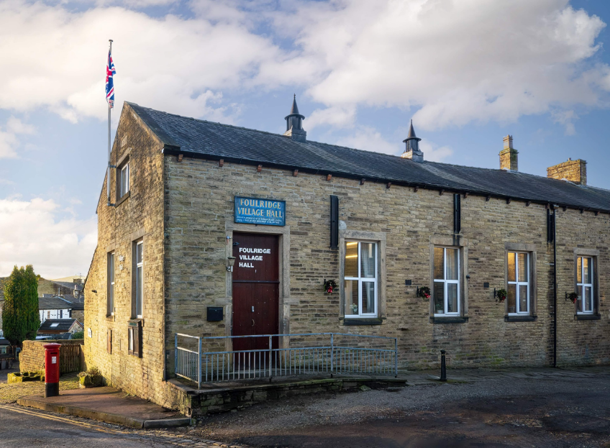
FOULRIDGE VILLAGE HALL TRUSTEES

Village Hall Trustees Meeting
Minutes of Meeting held at 7.00pm on Monday 2nd February 2026

1. Welcome and Apologies for Absence
The Chair, Cllr K. Salter, welcomed all attendees to the meeting.
Trustees Present:
Cllr K. Salter (Chair), Cllr Mulligan (Vice Chair), Cllr A. Salter, Cllr Rigby, Cllr Halliday, Cllr Robinson, Cllr Dixon, Cllr Whitfield
Also Present: Cllr Knowles, Mr Eccles (Caretaker)
Apologies: None

2. Approval of Previous Minutes
The minutes of the previous meeting were approved as a true and accurate record.

3. Matters Arising

There were no matters arising.

4. Village Hall Update
Caretaker’s Report:
The Caretaker advised that there were no new issues to report. Village Hall bookings were currently quiet.

5. Finance Report
The following invoices for January were reviewed and approved for payment:
British Gas Gas 03.12.25-02.01.26 | 198.09 | 17.01.26
Box of 3000 Paper Towels | 24.99 | 06.01.26
Waterplus 07.12.25-07.01.26 | 82.74 | 26.01.26
British Gas - Electric 14.12.25-14.01.26 | 161.65 | 28.01.26
Amazon - Kitchen items | 44.07 | 19.01.26
Total | 511.54

Resolved:
The invoices totalling £511.54 were approved for payment.
The budget was reviewed, and it was agreed that the Village Hall budget for 2026/2027 would remain unchanged.

6. Correspondence

No correspondence was received

Date of Next Meeting
Monday 2nd March 2026 at 7:00pm

