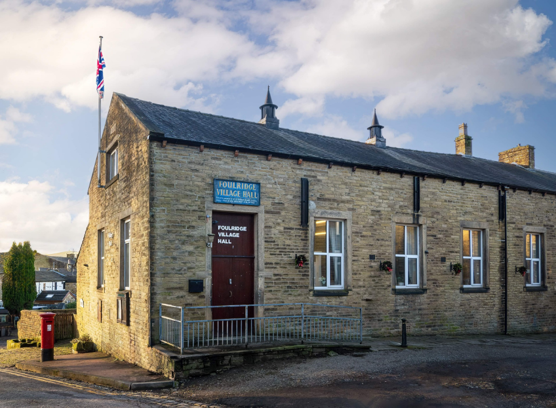
FOULRIDGE VILLAGE HALL TRUSTEES

Village Hall Trustees Meeting
Minutes of Meeting held at 7.00pm on Monday 3rd November 2025

1. Welcome and Apologies for Absence
The Chair, Cllr K. Salter, welcomed all attendees to the meeting.
Trustees Present:
Cllr K. Salter (Chair), Cllr Mulligan (Vice Chair), Cllr A. Salter, Cllr Rigby, Cllr Dixon, Cllr Whitfield, Cllr Halliday
Also Present: Cllr Knowles, Mr Eccles (Caretaker),
Apologies: Cllr Nicholson

2. Approval of Previous Minutes
The minutes of the previous meeting were approved as a true and accurate record.

3. Matters Arising

There were no matters arising.

4. Village Hall Update
Caretaker’s Report:
- No new maintenance issues have been reported.
User Groups and New Bookings:
- The caretaker noted that hall bookings remain busy over the next couple of months. Updated booking information has been shared with Cllr Mulligan.

5. Finance Report
The following invoices for October 2025 were reviewed and approved for payment:
British Gas Gas 04.09.25-03.10.25 | 37.38 | 17.10.25
Waterplus 07.09.25-03.10.25 | 76.20 | 27.10.25
British Gas - Electric 14.03.25-14.10.25 | 60.06 | 28.10.25
Electrical Sale Barrowford | 649.00 | 25.10.25
Hey Farm Plants | 100.00 | 25.10.25

6. Correspondence

No correspondence was received

Date of Next Meeting
Monday 1st December 2025 at 7:00pm

