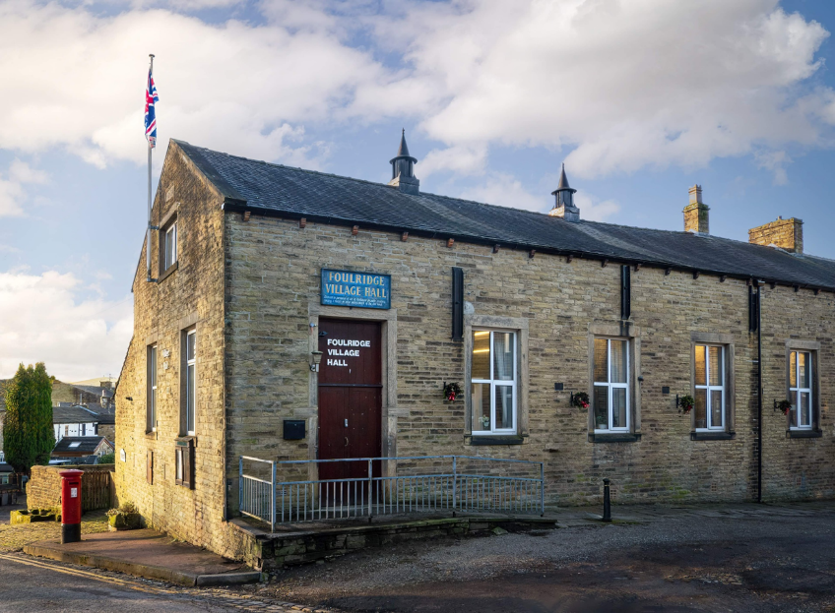
FOULRIDGE VILLAGE HALL TRUSTEES

Village Hall Trustees Meeting
Minutes of Meeting held at 7.00pm on Monday 1st December 2025

1. Welcome and Apologies for Absence
The Chair, Cllr K. Salter, welcomed all attendees to the meeting.
Trustees Present:
Cllr K. Salter (Chair), Cllr Mulligan (Vice Chair), Cllr A. Salter, Cllr Rigby, Cllr Nicholson, Cllr Whitfield, Cllr Halliday
Also Present: Cllr Knowles, Mr Eccles (Caretaker), Sara Robinson
Apologies: Cllr Dixon

2. Approval of Previous Minutes
The minutes of the previous meeting were approved as a true and accurate record.

3. Matters Arising

Cllr Knowles provided an update on the table tennis table. A trial was undertaken by various councillors and it was decided that it was not really suitable; noting that it had several issues and was quite outdated. An option of purchasing a new, good-quality table will be investigated, however the trustees agreed that they would first assess the level of interest before proceeding any further.

4. Village Hall Update
Caretaker’s Report:
- No new maintenance issues have been reported.
User Groups and New Bookings:
- The caretaker noted that hall bookings remain busy over the next couple of months.

5. Finance Report
The following invoices for November 2025 were reviewed and approved for payment:
British Gas Gas 03.10.25-03.11.25 | 51.74 | 17.11.25
Asda - Bin Liners/Tea Towels | 9.80 | 04.11.25
Waterplus 07.10.25-03.11.25 | 73.09 | 27.11.25
British Gas - Electric 14.10.25-14.11.25 | 97.37 | 28.11.25

6. Correspondence

No correspondence was received

Date of Next Meeting
Monday 5th January 2026 at 7:00pm

