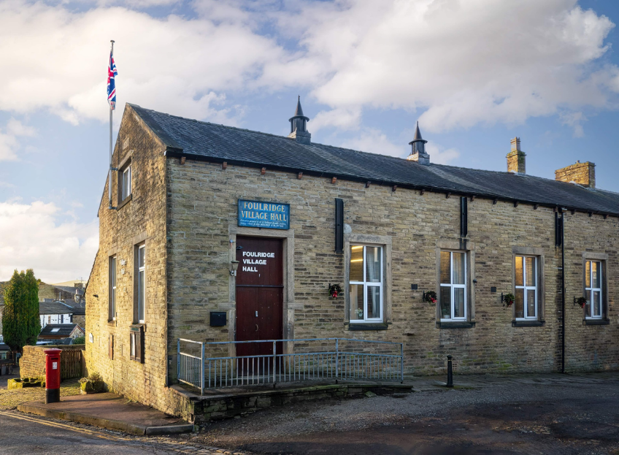
FOULRIDGE VILLAGE HALL TRUSTEES

Village Hall Trustees Meeting
Minutes of Meeting held at 7.00pm on Monday 6th October 2025

1. Welcome and Apologies for Absence
The Chair, Cllr K. Salter, welcomed all attendees to the meeting.
Trustees Present:
Cllr K. Salter (Chair), Cllr Mulligan (Vice Chair), Cllr A. Salter, Cllr Rigby, Cllr Nicholson, Cllr Whitfield, Cllr Halliday
Also Present: Cllr Knowles, Mr Eccles (Caretaker),
Apologies: Cllr Dixon

2. Approval of Previous Minutes
The minutes of the previous meeting were approved as a true and accurate record.

3. Matters Arising
- Potholes: Cllr K. Salter confirmed that the potholes directly outside the Village Hall have now been filled.
- Main Door: A contractor has inspected the main door and recommended that it be refurbished and insulated. A decision will be made once costings are received.

4. Village Hall Update
Caretaker’s Report:
- There are currently no new maintenance issues.
- A few leaks have been noted in the gents’ toilets, likely due to recent heavy rain. The situation will be monitored.

User Groups and New Bookings:
- The newly booked group, Performing Minds, has withdrawn due to restrictions identified in the hall’s risk assessment limiting the areas they could use.

5. Finance Report
The following invoices for September 2025 were reviewed and approved for payment:
27.06.25 | Sainsbury's - Bin Liners | 4.95 | 02.09.25
01.09.25 | Asda - Bin Liners | 8.70 | 02.09.25
19.07.25 | Peters Electicals - 4ft tube | 4.99 | 02.09.25
03.09.25 | British Gas Gas 04.08.25-03.09.25 | 11.09 | 17.09.25
09.09.25 | Waterplus 07.08.25-03.09.25 | 68.26 | 29.09.25
15.09.25 | British Gas - Electric 14.03.25-15.09.25 | 76.22 | 29.09.25
 | Total | £174.21

6. Correspondence

No correspondence was received

Date of Next Meeting
Monday 3rd November 2025 at 7:00pm

