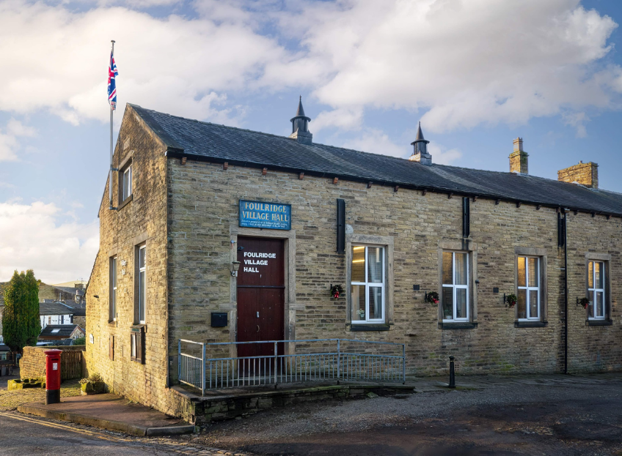
FOULRIDGE VILLAGE HALL TRUSTEES

Village Hall Trustees Meeting
Minutes of Meeting held at 7.00pm on Monday 1st September 2025

1. Welcome and Apologies for Absence
The Chair, Cllr K. Salter, welcomed all attendees to the meeting.
Trustees Present:
Cllr K. Salter (Chair), Cllr Mulligan (Vice Chair), Cllr A. Salter, Cllr Rigby
Also Present: Cllr Knowles, Mr Eccles (Caretaker),
Apologies: Cllr Nicholson, Cllr Whitfield, Cllr Halliday, Cllr Dixon

2. Approval of Previous Minutes
The minutes of the previous meeting were approved as a true and accurate record.

3. Matters Arising
There were no matters arising
Cllr Dixon, Cllr Halliday and Cllr Rigby have been added as Trustees of the Village Hall with the Charities Commission.

4. Village Hall Update
Caretaker’s Report:
- Maintenance: Cllr Mulligan reported that following investigation, the water emerging from the wall is not the result of a leak.
User Groups and New Bookings:
- A new group, Performing Minds, has booked the hall every Thursday from 4:30pm to 6:00pm.
- Stage Door has booked the hall for three evenings at the end of November.

Other Updates:
- Main Door Refurbishment: Cllr K. Salter advised that a contractor will inspect the main doors on Tuesday.
- A contractor is also scheduled to assess potential solutions for filling the potholes on the road outside the entrance of the Village Hall.

5. Finance Report
The following invoices for July and August 2025 were reviewed and approved for payment:
British Gas Gas 03.06.25-03.07.25 | 16.19 | 17.07.25
Waterplus 07.06.25-03.07.25 | 196.94 | 22.07.25
British Gas - Electric 14.03.25-14.07.25 | 78.42 | 28.07.25
Total | 291.55

British Gas Gas 03.07.25-04.08.25 | 16.47 | 18.08.25
Waterplus 07.07.25-04.08.25 | 102.06 | 22.08.25
British Gas - Electric 14.03.25-14.08.25 | 80.75 | 28.08.25
Total | £199.28

6. Correspondence

No correspondence was received

Date of Next Meeting
Monday 6th October 2025 at 7:00pm

