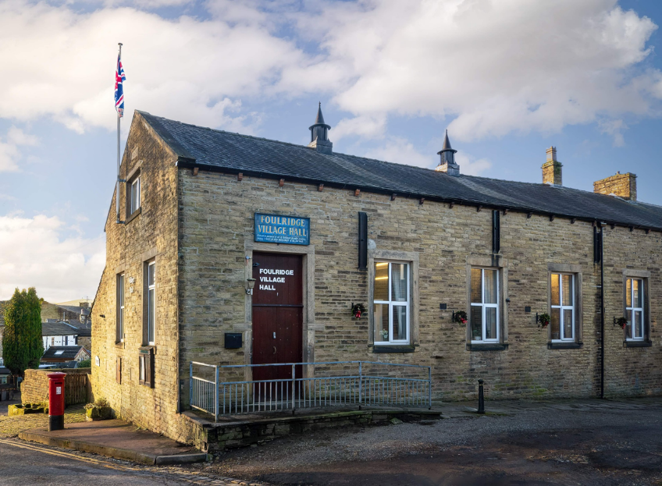
FOULRIDGE VILLAGE HALL TRUSTEES

Village Hall Trustees Meeting
Minutes of Meeting held at 7.00pm on Monday 2nd June 2025

1. Welcome and Apologies for Absence
The Chair, Cllr K. Salter, welcomed all attendees to the meeting.
Trustees Present:
Cllr K. Salter (Chair), Cllr Mulligan (Vice Chair), Cllr A. Salter, Cllr Nicholson, Cllr
Whitfield
Also Present: Cllr Knowles, Mr Eccles (Caretaker)
Apologies: None

2. Approval of Previous Minutes
The minutes of the previous meeting were approved as a true and accurate record.

3. Matters Arising
There were no matters arising from the previous minutes.

4. Village Hall Update
Caretaker’s Report:
- The Caretaker confirmed that the Fire Risk Assessment has been completed. The formal report is expected to be received shortly.
User Group Activities & New Bookings:
- The line dancing class has expanded and will now be offering an additional session on Wednesday mornings.

Other Updates:
- Cllr K. Salter confirmed that a new Village Hall sign has been ordered.
- It was noted that the no parking sign on the front door also requires replacement.

5. Finance Report
The following invoices for May 2025 were reviewed and approved for payment:
British Gas Gas 03.04.25-03.05.25 | 27.14 | 17.05.25
Waterplus 07.04.25-07.05.25 | 95.51 | 22.05.25
Staple Gun and Staples | 10.50 | 13.05.25
British Gas Electric 14.03.25-15.05.25 | 65.15 | 29.05.25
Total | 198.30

6. Correspondence

No correspondence was received

Date of Next Meeting
Monday 7th July 2025 at 7:00pm

