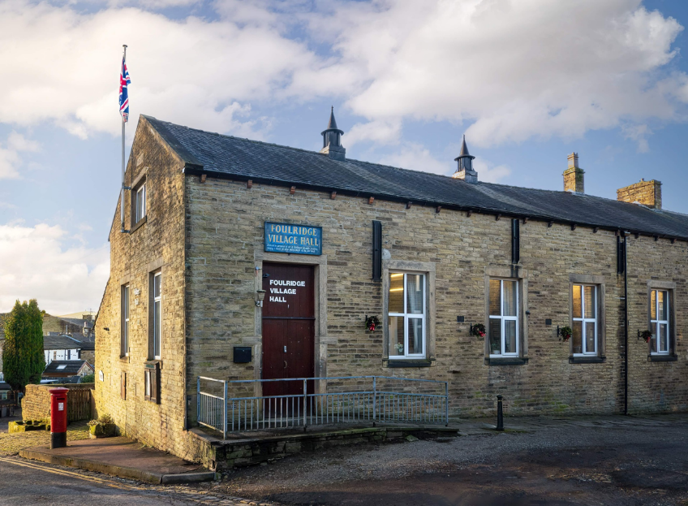
FOULRIDGE VILLAGE HALL TRUSTEES

Village Hall Trustees Meeting
Minutes of Meeting held at 7.00pm on Monday 12th May 2025

1. Welcome and Apologies for Absence
The Chair, Cllr K. Salter, welcomed all attendees to the meeting.
Trustees Present:
Cllr K. Salter (Chair), Cllr Mulligan (Vice Chair), Cllr A. Salter, Cllr Nicholson, Cllr
Whitfield
Also Present: Cllr Knowles, Mr Eccles (Caretaker)
Apologies: None

2. Approval of Previous Minutes
The minutes of the previous meeting were approved as a true and accurate record.

3. Matters Arising
There were no matters arising from the previous minutes.

4. 2025 Confirmation of Trustees
All current trustees confirmed their willingness to continue serving on the Board for the 2025/26 financial year.
Cllr K Salter was nominated and unanimously elected as Chair of the Trustees for the upcoming year.

5. Village Hall Update
Maintenance:
The Caretaker confirmed that there were no new maintenance issues to report.
User Groups and Bookings:
A new educational tuition group has booked the hall on Thursdays from 4:00 PM to 6:00 PM, starting in September 2025.

6. Finance Report
The following invoices for April 2025 were approved for payment:
British Gas Gas 03.03.25-03.04.25 | 111.72 | 17.04.25
Cleaning products | 7.14 | 08.04.25
Waterplus 07.03.25-07.04.2 | 76.47 | 23.04.25
British Gas Electric 14.03.25-14.04.25 | 99.94 | 28.04.25
Total | 295.27

7. Correspondence
Cllr K. Salter reported that two companies have expressed interest in supplying a new front door for the Village Hall. Further details will be reviewed at a future meeting.

He also noted that the Village Hall sign requires refreshing. A recommendation was made to retain the current frame for heritage purposes and to have the lettering professionally restored. Cllr K Salter knows a signmaker with previous positive work and will follow up.

Date of Next Meeting
Monday 2nd June 2025 at 7:00pm

