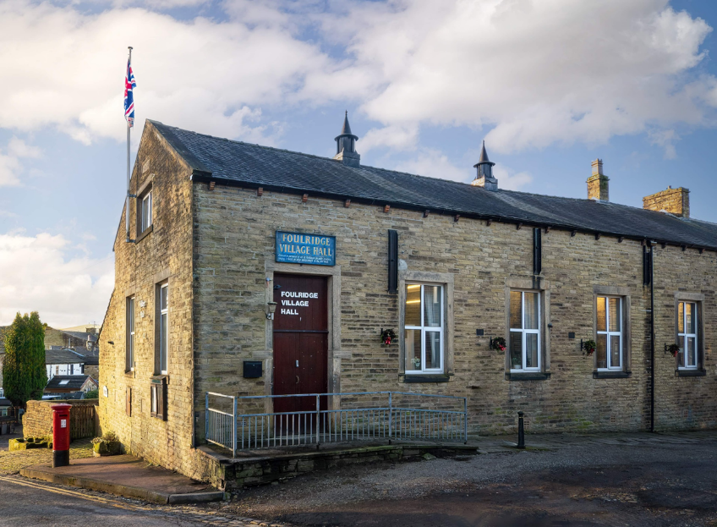
FOULRIDGE VILLAGE HALL TRUSTEES

Village Hall Trustees Meeting
Minutes of Meeting held at 7.00pm on Monday 7th April 2025

1. Welcome and Apologies for Absence
The Chair, Cllr K. Salter, welcomed all attendees to the meeting.
Trustees Present:
Cllr K. Salter (Chair), Cllr Mulligan (Vice Chair),, Cllr A. Salter, Cllr Nicholson, Cllr
Whitfield
Also Present: Cllr Knowles, Eccles (Caretaker)
Apologies: None

2. Approval of Previous Minutes
The minutes of the previous meeting were approved as a true and accurate record.

3. Matters Arising
There were no matters arising from the previous minutes.

4. Village Hall Update
Maintenance Issues
The Caretaker reported ongoing issues with the water system pressure which is affecting the operation of the boiler. He suggested consideration be given to renovating the complete heating system within the hall.
Decision: Regarding the heating problem the trustees agreed to investigate the cost of a replacement system during the summer months.

User Groups / Bookings
The Caretaker reported that the newly introduced line dancing class had been well received

5. Annual Safety Checks
The Caretaker informed the Trustees that the following annual inspections have been scheduled:
- Portable Appliance Testing (PAT)
- Emergency Lighting Test
- Fire Extinguisher Service
The Caretaker will also arrange for the annual Gas Safety Check.
The Clerk advised that the Fire Risk Assessment is now due, as the last was completed 24 months ago.
Decision: The Trustees requested that the Caretaker contact Kilblaze to schedule this.

6. Finance Report
The following invoices for March 2025 were approved for payment:
Item | Amount | Date
British Gas (Gas 02.02.25 – 03.03.25) | £141.72 | 17.03.25
Kitchen wall clock | £8.49 | 04.03.25
Toilet rolls | £8.98 | 04.03.25
Flow tubes | £11.98 | 04.03.25
Waterplus (07.02.25 – 07.03.25) | £52.59 | 22.03.25
British Gas (Electricity 14.12.24 – 14.03.25) | £48.56 | 28.03.25
Total | £272.32

The Chair informed the Trustees that the 2024/25 Budget had been reviewed by the Financial Sub-Committee and showed a balanced account which will now be forwarded.

7. Correspondence
No correspondence was received during the month.

Date of Next Meeting
Monday, 12th May 2025 at 7:00pm

