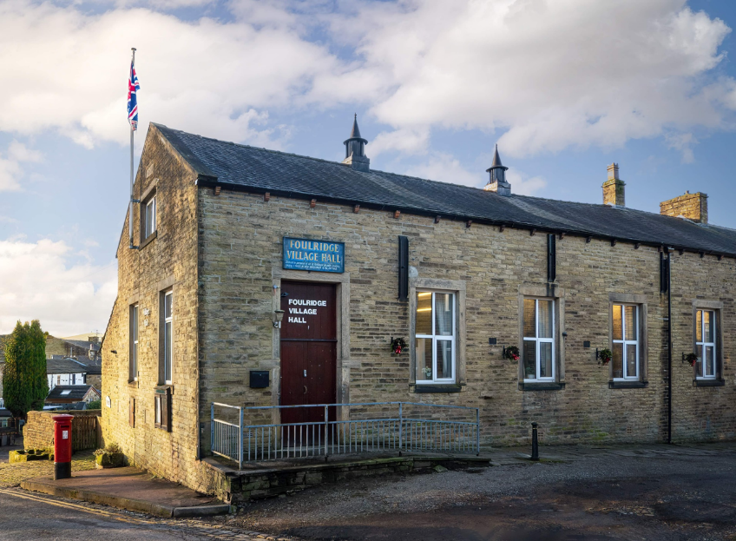
FOULRIDGE VILLAGE HALL TRUSTEES

Village Hall Trustees Meeting
Minutes of Meeting held at 7.00pm on Monday 3rd February 2025

1. Welcome and approve apologies
The Chair, Cllr K Salter, welcomed all to the meeting.
Attendance: Cllr K Salter (Chair), Cllr Mulligan (Vice Chair), Cllr Whitfield, Cllr Knowles, Cll A Salter, Cllr Nicholson

Apologies: These were accepted for Mr Eccles (the Caretaker)

2. Approve the Draft Minutes of the previous meeting as a correct record
The Minutes were approved as a true and correct record.

3. Matters Arising
No Trustees had any updates regarding the previous meeting’s minutes.

Cllr Mulligan asked, on behalf of the Caretaker, for permission for the heating to be put on for an hour in the morning and an hour in the evening to help alleviate the damp and condensation in the building.
Decision: Trustees agreed.

4. Village Hall Update
Maintenance requirements
It was reported that the boiler is starting to struggle and may not be working efficiently. Cllr
Whitfield mentioned it could just be an issue with the radiators due to age of them.
Decision: Trustees agreed to inspect the system over the summer and decide if any replacements are needed.

User Groups/Village Hall Bookings
Event bookings are steady but there are no new regular user groups.

5. Finance Report
The following invoices for January were approved for payment.

British Gas Gas 04.12.24-02.01.25 | 86.16 | 16.01.25
Asda - Bin Liners & Handwah | 12.70 | 07.01.25
Digital Fridge Thermometer | 4.99 | 07.01.25
Hand Towels | 31.19 | 07.01.25
Waterplus 07.12.24-07.01.25 | 72.67 | 23.01.25
British Gas Electricity 14.12.24-15.01.25 | 124.92 | 29.01.25
Total | 332.63

Cllr K Salter mentioned that the Financial Sub-Committee had looked at the 2024/25 budget and no adjustments to the budget were required. After discussion, Trustees agreed to carry forward the expenditure funding to the 2025/26 Budget but increase the expected water cost to £2000.

Cllr Knowles reported he had checked the high water bill we received for December and said it was accurate. He stated that this was due to the readings on the previous bills being estimated.
Decision: The Caretaker will send monthly readings to the Clerk so accurate readings are submitted to the water company.

6. Correspondence
No correspondence has been received this month.

Cllr Mulligan reported that the contractor had contacted him and said that he is still chasing the manufacturers in regards to the new village hall front doors.

DATE OF NEXT MEETING: Monday 3rd March 2025 at 7pm

