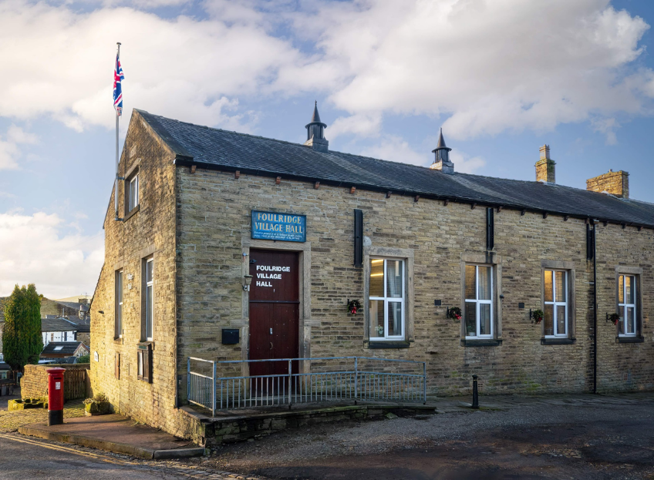
FOULRIDGE VILLAGE HALL TRUSTEES

Village Hall Trustees Meeting
Minutes of Meeting held at 7.00pm on Monday 6th January 2025

1. Welcome and approve apologies
The Chair, Cllr K Salter, welcomed all to the meeting.
Attendance: Cllr K Salter (Chair), Cllr Mulligan (Vice Chair), Cllr Whitfield, Cllr Knowles, Cll A Salter and Mr Eccles (Caretaker)

Apologies: These were apporoved for Cllr Nicholson

2. Approve the Draft Minutes of the previous meeting as a correct record
The Minutes were approved as a true and correct record.

3. Matters Arising
No Trustees had any updates regarding the previous meeting’s minutes.

4. Village Hall Update
Maintenance requirements
The Caretaker reported that the damp area on the wall outside the meeting room has improved and there seems to be no other maintenance issues at the moment.

User Groups/Village Hall Bookings
The caretaker reported that event bookings are steady but are no new regular user groups.
Decision: Cllr A Salter to advertise on Facebook again and will send the advert to Cllr Knowles to put on the website.

5. Finance Report
The following invoices for December were approved for payment.

British Gas Gas 03.11.24-04.12.24 | 69.36 | 18.12.24
Waterplus 07.11.24-07.12.24 | 538.20 | 21.12.24
British Gas Electricity 14.10.24-14.12.24 | 73.26 | 28.12.24
Total | 680.82

Cllr K Salter queried the high water bill for December and the Clerk advised that previous bills were estimates and the bill is from an actual read. Cllr Knowles suggested calculating a bill by looking at a longer time period and using accurate readings.
Decision: The Clerk will send Cllr Knowles the recent December bill and a previous accurate bill so he can calculate and compare before the next sub finance committee meeting.

6. Correspondence
No correspondence has been received this month.

DATE OF NEXT MEETING: Monday 3rd February 2025 at 7pm

