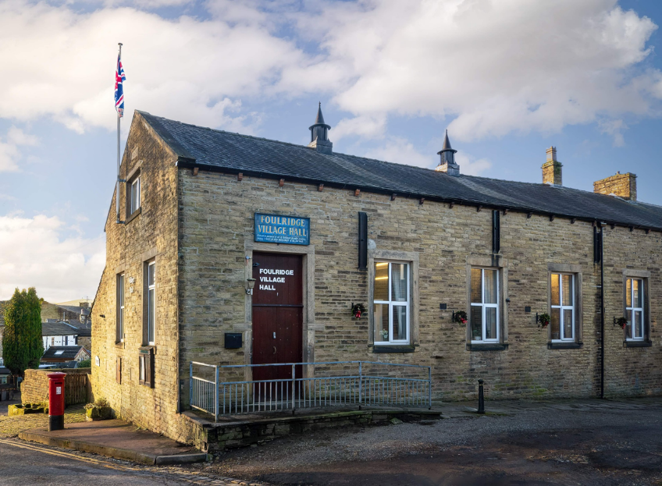
FOULRIDGE VILLAGE HALL TRUSTEES

Village Hall Trustees Meeting
Minutes of Meeting held at 7.00pm on Monday 2nd December 2024

1. Welcome and approve apologies
The Vice Chair, Cllr Mulligan, welcomed all to the meeting.
Attendance: Cllr Mulligan (Vice Chair), Cllr Whitfield, Cllr Knowles, Cllr Nicholson and Mr Eccles (Caretaker)

Apologies: Cllr K Salter, Cllr A Salter

2. Approve the Draft Minutes of the previous meeting as a correct record
The Minutes were approved as a true and correct record.

3. Matters Arising
No Trustees had any updates regarding the previous meeting’s minutes.

4. Village Hall Update
Maintenance requirements
The Caretaker reported that the leak outside the meeting room is still visible and appears to have deteriorated. Cllr Mulligan thinks it may be due to condensation and suggested purchasing a dehumidifier. Cllr Knowles felt that natural ventilation would work better.

User Groups/Village Hall Bookings
The caretaker reported that event bookings are steady but are no new regular user groups. Cllr Knowles once again mentioned that trustees should be more proactive and suggested approaching activity groups and asking them if they would like to run an event at the village hall.
Decision: Trustees to ask Cllr A Salter to advertise on Facebook on a weekly basis and maybe include a post asking what kind of activities residents they would like to see at the village hall.

5. Finance Report
The following invoices for November were approved for payment.

Waterplus 07.09.24-07.10.24 | 98.69 | 01.11.24
Sainsbury's - Bin Bags | 7.38 | 05.11.24
Sainsbury's - Handwash | 4.00 | 05.11.24
British Gas Gas 03.10.24-03.11.24 | 43.09 | 17.11.24
Waterplus 07.10.24-07.11.24 | 104.06 | 21.11.24
British Gas Electricity 14.10.24-14.11.24 | 97.71 | 28.11.24

6. Correspondence
No correspondence has been received this month.

DATE OF NEXT MEETING: Monday 6th January 2025 at 7pm

