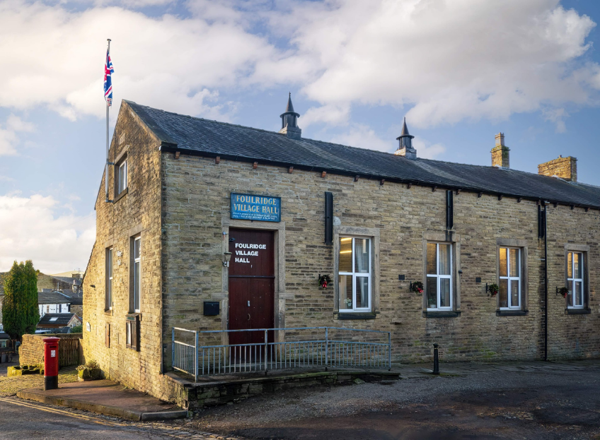
FOULRIDGE VILLAGE HALL TRUSTEES

Village Hall Trustees Meeting
Minutes of Meeting held at 7.00pm on Monday 7th October 2024

1. Welcome and approve apologies
The Chair, Cllr K Salter, welcomed all to the meeting.
Attendance: Cllr K Salter (Chair), Cllr Mulligan (Vice Chair), Cllr A Salter, Cllr Whitfield, Cllr Knowles, Cllr Nicholson and Mr Eccles (Caretaker)

Apologies: None

2. Approve the Draft Minutes of the previous meeting as a correct record
The Minutes were approved as a true and correct record.

3. Matters Arising
Cllr K Salter reported that a Social Media post has been published promoting the Village Hall.

4. Village Hall Update
Maintenance requirements
The Caretaker reported that he has noticed a slight leak again outside the meeting room. It is presumed this is coming from the roof.
Decision: Trustees agreed to contract our roofing specialist to investigate the problem, see where the leak is coming from and make repairs.

New Village Hall Bookings
The Caretaker advised that one of the regular user groups has taken on an extra day and party bookings have started to increase.
Cllr K Salter mentioned that on the 27th October at 12:00the hall is booked for the Freeman of the Parish presentation to Gregg Stevenson

5. Finance Report
The following invoices for September were approved for payment.

British Gas Gas 05.08.24-03.09.24 | 14.37 | 17.09.24
Waterplus 07.08.24-07.09.24 | 104.06 | 21.09.24
British Gas Electricity 06.07.24-14.09.24 | 58.17 | 28.09.24
Total | 176.60

6. Correspondence
No correspondence has been received this month.

DATE OF NEXT MEETING: Monday 4th November 2024 at 7pm

