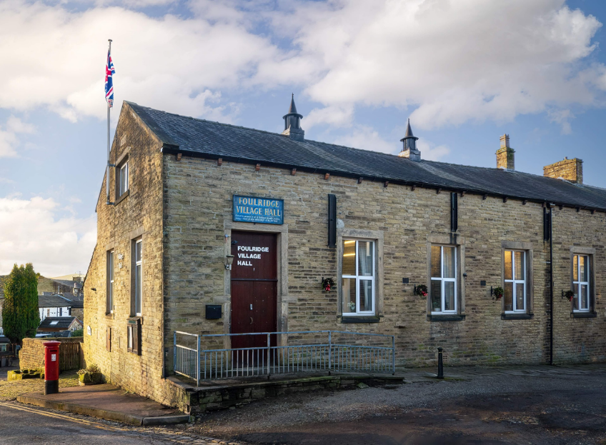
FOULRIDGE VILLAGE HALL TRUSTEES

Village Hall Trustees Meeting
Minutes of Meeting held at 7.00pm on Monday 4th November 2024

1. Welcome and approve apologies
The Chair, Cllr K Salter, welcomed all to the meeting.
Attendance: Cllr K Salter (Chair), Cllr Mulligan (Vice Chair), Cllr A Salter, Cllr Whitfield, Cllr Knowles, Cllr Nicholson and Mr Eccles (Caretaker)

Apologies: None

2. Approve the Draft Minutes of the previous meeting as a correct record
The Minutes were approved as a true and correct record.

3. Matters Arising
No Trustees had any updates regarding the previous meeting’s minutes.

4. Village Hall Update
Maintenance requirements
The Caretaker reported that the roofing contractor replaced a broken roof slate and this may have been the cause of the leak outside the meeting room. There appears to be less damp in the area now.
Decision: The Chair asked the Caretaker to monitor the condition of the wall and give Trustees an update in December.

New Village Hall Bookings
A children’s Halloween event was held at the village hall. This was organised by a group of parents from the village. Cllr Mulligan reported that the event was very well attended and was a success.

5. Finance Report
The following invoices for October were approved for payment.

British Gas Gas 03.09.24-03.10.24 | 30.93 | 18.10.24
British Gas Electricity 06.07.24-14.10.24 | 52.50 | 28.10.24
Total | 83.43

6. Correspondence
No correspondence has been received this month.

DATE OF NEXT MEETING: Monday 2nd December 2024 at 7pm

