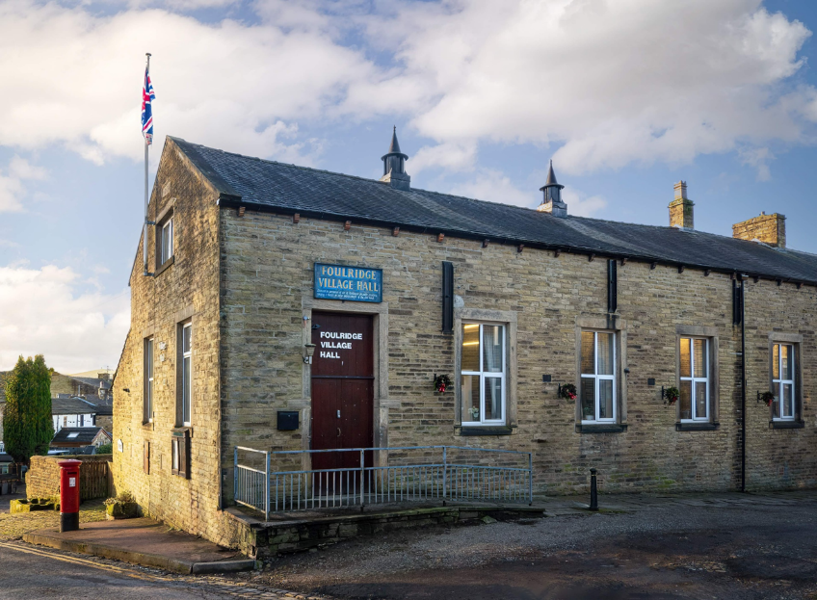
FOULRIDGE VILLAGE HALL TRUSTEES

Village Hall Trustees Meeting
Minutes of Meeting held at 7.00pm on Monday 8th July 2024

1. Welcome and approve apologies
The Vice Chair, Cllr P Mulligan, welcomed all to the meeting.
Attendance: Cllr Mulligan (Vice Chair), Cllr A Salter, Cllr Whitfield, Cllr Knowles, Mr Eccles (Caretaker)

Apologies: Cllr K Salter, Cllr Nicholson

Declarations of Interest: None declared.

2. Approve the Draft Minutes of the previous meeting as a correct record
The Minutes were approved as a true and correct record.

3. Matters Arising
Trustees’ updates on any content from the previous meeting will be covered under the agenda items.

4. Village Hall Update
Maintenance requirements
The Caretaker advised that there were no maintenance issues to report.

New Village Hall Bookings
There are currently two new bookings for the hall - Pendle Artists and one private booking. Two regular user groups are continuing with their bookings and one may return in September.
Cllr Knowles voiced again the importance of being proactive in advertising the hall availability.
Cllr Mulligan asked if we could hold off actively looking for groups to fill in the available village hall spaces until he has finished discussing possible art classes by Pendle Artists. We could still advertise Saturday/Sunday parties and events.
Decision: Trustees agreed that the hall should be advertised through social media and on the website

5. Village Hall Renovation
Cllr Mulligan reported that all the jobs have been completed on time apart from the front door due to manufacturing issues. He mentioned that there are a few minor snagging issues that will need rectifying.

6. Finance Report
The following invoices for June were approved for payment.

British Gas Electricity 17.03.24-20.05.24 | 71.44 | 03.06.24
British Gas Gas - 04.05.24-05.06.24 | 25.87 | 19.06.24
Waterplus 07.05.24-06.06.24 | 36.28 | 22.06.24
British Gas Electricity 17.03.24-19.06.24 | 69.20 | 03.07.24
Pendle Borough Council - Trade Refuse | 106.86 | 20.06.24
Total | 309.65

7. Correspondence
No correspondence was received this month.

DATE OF NEXT MEETING: Monday 2nd September 2024 at 7pm

