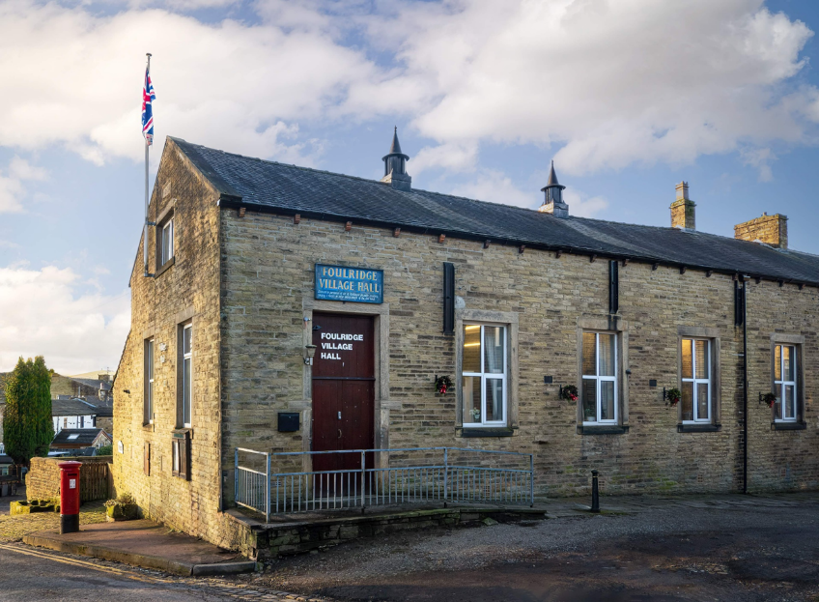
FOULRIDGE VILLAGE HALL TRUSTEES

Village Hall Trustees Meeting
Minutes of Meeting held at 7.00pm on Monday 2nd September 2024

1. Welcome and approve apologies
The Chair, Cllr K Salter, welcomed all to the meeting.
Attendance: Cllr K Salter (Chair), Cllr Mulligan (Vice Chair), Cllr A Salter, Cllr Whitfield, Cllr Knowles, Cllr Nicholson and Mr Eccles (Caretaker)

Apologies: None

Declarations of Interest: None declared.

2. Approve the Draft Minutes of the previous meeting as a correct record
The Minutes were approved as a true and correct record.

3. Matters Arising
Trustees’ updates on any content from the previous meeting will be covered under the agenda items.

4. Village Hall Update
Maintenance requirements
The Caretaker advised that there were no maintenance issues to report.

New Village Hall Bookings
The two regular user groups are continuing with their bookings. One previous regular user has now found an alternative venue. Party bookings are steady.
Decision: Trustees agreed that the hall should be advertised through social media and on the website

5. Village Hall Renovation
Cllr Mulligan reported that there is still no update on the front doors and that no order has been placed for them yet.
Cllr Knowles advised that all the grant money from the LEF has now been received and showed the plaque sent from them which will be displayed in the hall.

6. Finance Report
The following invoices for July and August were approved for payment.

System Hygiene - Evans Clean and Shine | 8.99 | 07.07.24
Britsh Gas Gas 05.06.24-06.06.24 | 30.66 | 20.07.24
Sainsbury's - Bin Bags | 8.25 | 09.07.24
Asda - Bin Liners | 8.70 | 09.07.24
Amazon - Mop Head Replacements | 12.99 | 09.07.24
Waterplus 07.06.24-07.07.24 | 98.69 | 24.07.24
British Gas Electricity 17.03.24-06.07.24 | 57.43 | 28.07.24
Total | 216.72

05.08.2024 | British Gas Gas 06.07.24-05.08.24 | 18.22
08.08.2024 | Waterplus 07.07.24-07.08.24 | 104.06
14.08.2024 | British Gas Electricity 06.07.24-14.08.24 | 95.77
 | Total | £218.05

7. Correspondence
No correspondence has been received this month.

DATE OF NEXT MEETING: Monday 7th October 2024 at 7pm

