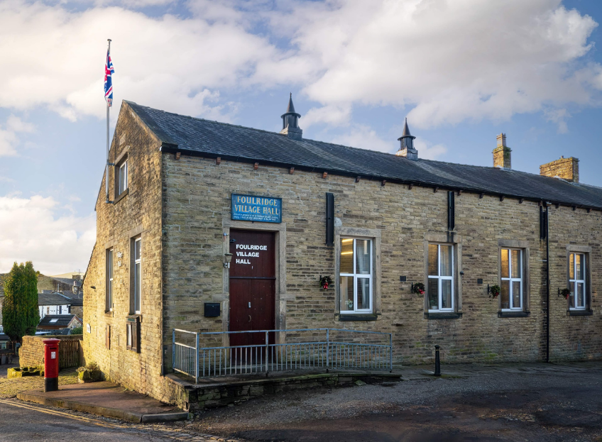
FOULRIDGE VILLAGE HALL TRUSTEES

Village Hall Trustees Meeting
Minutes of Meeting held at 7.00pm on Monday 3rd June 2024

1. Welcome and approve apologies
The Chair, Cllr K Salter, welcomed all to the meeting.
Attendance: Cllr K Salter (Chair), Cllr Mulligan (Vice Chair), Cllr A Salter, Cllr Whitfield, Cllr Nicholson, Mr Eccles (Caretaker)

Apologies: Cllr Knowles
Declarations of Interest: None declared.

2. Approve the Draft Minutes of the previous meeting as a correct record
The Minutes were approved as a true and correct record.

3. Matters Arising
Trustees’ updates on any content from the previous meeting will be covered under the agenda items.

4. Village Hall Update
Maintenance requirements
The Caretaker advised that water marks have reappeared where it has previously leaked in. Trustees are aware that this is due to the hall needing re-roofing.
He also advised that the building could do with another down-pipe to cope with the excess water. Cllr K Salter reported that this would be looked into during the renovations.

New Village Hall Bookings
There are currently no new bookings due to the hall being closed from the 10th June for renovation.

5. Village Hall Renovation
Cllr K Salter advised that the renovations are on track to start on the 10th June.
The contractor has informed that he has not had any contact from the painter and decorator. Cllr Mulligan agreed to chase this up.
Cllr K Salter mentioned paint colours still need to be chosen.
Decision: Cllr A. Salter and Cllr Mulligan were tasked with choosing the new colour new scheme opening up a trade account with a local company to purchase the paint.

6. Finance Report
The following invoices for May were approved for payment.

Waterplus 06.03.24-06.04.24 | 104.30 | 02.05.24
British Gas Electric 17.03.24-20.04.24 | 84.44 | 05.05.24
British Gas Gas - 03.04.24-04.05.24 | 67.61 | 18.05.24
Sainsbury's - Bin Bags | 8.25 | 08.05.24
Total | 264.60

7. Correspondence
No correspondence was received this month.

DATE OF NEXT MEETING: Monday 8th July 2024 at 7pm

