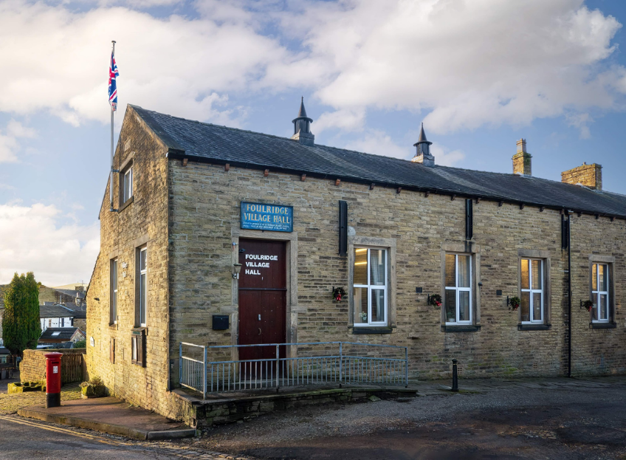
FOULRIDGE VILLAGE HALL TRUSTEES

Village Hall Trustees Meeting
Minutes of Meeting held at 7.00pm on Tuesday 7th May 2024

1. Welcome and approve apologies
The Chair, Cllr K Salter, welcomed all to the meeting.
Attendance: Cllr K Salter (Chair), Cllr Mulligan (Vice Chair), Cllr A Salter, Cllr Whitfield, Cllr Knowles, Mr Eccles (Caretaker)

Apologies: Cllr Nicholson
Declarations of Interest: None declared.

2. Approve the Draft Minutes of the previous meeting as a correct record
The Minutes were approved as a true and correct record.

3. Matters Arising
Trustees’ updates on any content from the previous meeting will be covered under the agenda items.

4. Village Hall Update
Maintenance requirements
The Caretaker advised that there are no new maintenance requirements at the moment.

New Village Hall Bookings
The Caretaker reported that he has received a couple of new enquires about the hall availability. He replied to them but, as yet, he hasn’t received any responses.

One current user group has informed the Clerk that they will be finding an alternative venue whilst the renovations are taking place but hopefully will be returning back in September.
Cllr Knowles suggested that we should be pro-active and contact the users once the renovation work has finished.
Decision: Trustees agreed that this would be the case and social media platforms will also be used to advertise the renovated hall.

Cllr K Salter advised that he has looked at the charging structure of similar venues in the local area. He referred to last month’s proposal to increase the charge for the use of the kitchen to £30.
Based on the findings the Trustees discussed the proposal.
Decision: Trustees agreed to increase the kitchen hire charge from £20 to £30

Cllr K Salter advised that the refurbishment of the Village Hall is due to start on the 10th June. This will include new upgraded window glass, new fire doors and external doors and new loft insulation. During the closure period, the hall will also be painted and decorated. One estimate for this work has been received and this will be discussed in the following Parish Council meeting.

The hall will be closed from the 10th June and is due to reopen on the 1st July.

5. Lancashire Environmental Fund
Cllr Knowles gave an update on the progress of the grant application and confirmed that all the deadlines have been met and responses have been made when needed. He advised that an official letter has been received confirming that the money has been granted.
He has since completed the acceptance form which outlines the terms and conditions and the project delivery and commencement form has been completed.

6. Finance Report
The following invoices for April were approved for payment.

17.03.2024 | British Gas Electric 16.06.23-17.03.24 | 89.33 | 02.04.24
03.04.2024 | British Gas Gas - 03.03.24-003.04.24 | 85.53 | 17.04.24
 | Total | 174.86

7. Correspondence

No correspondence was received this month.

DATE OF NEXT MEETING: Monday 3rd June 2024 at 7pm

