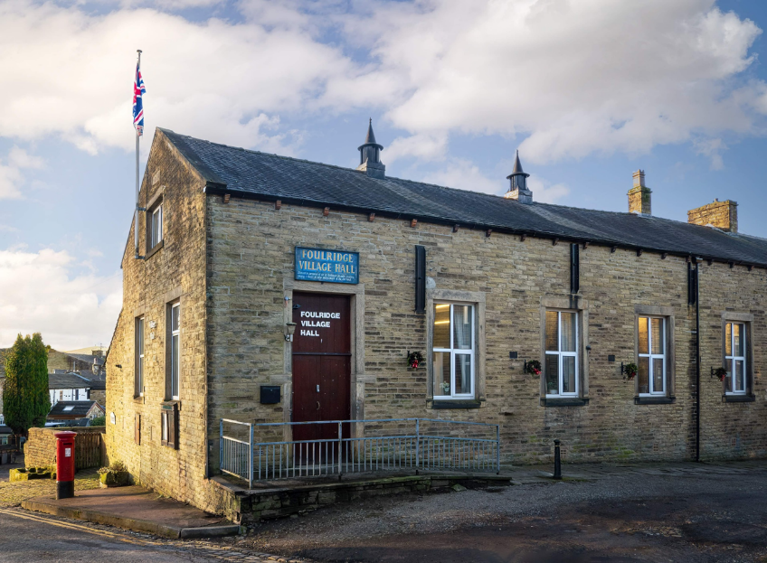
FOULRIDGE VILLAGE HALL TRUSTEES

Village Hall Trustees Meeting
Minutes of Meeting held at 7.00pm on Monday 4th March 2024

1. Welcome and approve apologies
The Vice Chair, Cllr P Mulligan, welcomed all to the meeting.
Attendance: Cllr Mulligan (Vice Chair), Cllr A Salter, Cllr Whitfield, Cllr Nicholson, Mr Eccles (Caretaker)
Cllr Knowles joined the meeting at 7.12pm.

Apologies: Cllr K Salter
Declarations of Interest: None declared.

2. Approve the Draft Minutes of the previous meeting as a correct record
The Minutes were approved as a true and correct record.

3. Matters Arising
Trustees’ updates on any content from the previous meeting will be covered under the
agenda items.

4. Village Hall Update
Maintenance requirements
The Caretaker advised that there does not appear to be any maintenance requirements at the moment. He confirmed that he has taken delivery of the cleaning supplies from
System Hygiene.
Decision: Trustees agreed payment of invoice for £134.77 from System Hygiene

User Group Activities
The Caretaker advised that the current Keep Fit class has added an extra day. She now has regular bookings on Monday, Tuesday, Thursday evenings and Saturday morning.

New Village Hall Bookings
Cllr Mulligan advised that Pendle Artists have booked for a weekend in July and he will be meeting with them this week to finalise the details. They are also considering booking the hall regularly and offering art classes.

5. Lancashire Environmental Fund
Cllr Mulligan advised that there has been no update on the outcome of the grant application as yet.

6. Finance Report
The following invoices for February were approved for payment.

British Gas Gas 02.01.24-04.02.24 | 102.27 | 18.02.24
Amazon - Handtowels | 28.00 | 08.02.24
Sainsbury's - Cleaning Supplies | 15.08 | 08.02.24
Waterplus 06.12.23-05.02.24 | 205.60 | 27.02.24
British Gas Electricity 16.06.23-19.02.24 | 79.99 | 04.03.24
Total | 430.94

7. Correspondence

No correspondence was received this month.

DATE OF NEXT MEETING: Monday 8th April 2024 at 7pm

